*Florida International University*

*School of Computing and Information Sciences*

Software Engineering Focus

Feature Document

User Story ID <NVOS-22 Create Profile>

**Name:** Bryan Bastida

**Team Member(s):** Andrew Castillo

Bryan Bastida

**Project:** EnvoScholar

**Product Owner(s)**: Mark Finlayson

**Mentor(s)**: Masoud Sadjadi

**Instructor**: Masoud Sadjadi

**User Story Name:**

* Description: As a user, I want to create my own profile, so that I can manage my searches and results.

Acceptance Criteria

* User clicks Account
* User fills out page with their cridentials
* User clicks Sign Up

**Use Case**

* Name: Create Profile
* Actor: User, webpage, user server, MongoDB
* Preconditions: User has clicked on Account and is now at the Sign Up page

User has entered credentials

* Description <Flow of events>: User clicks on Account and is now at the Sign Up page

User adds their full name, e-mail, and password in the input

boxes

User clicks on sign up

User will be displayed a message saying their account has

been created

**Use Case Diagram**

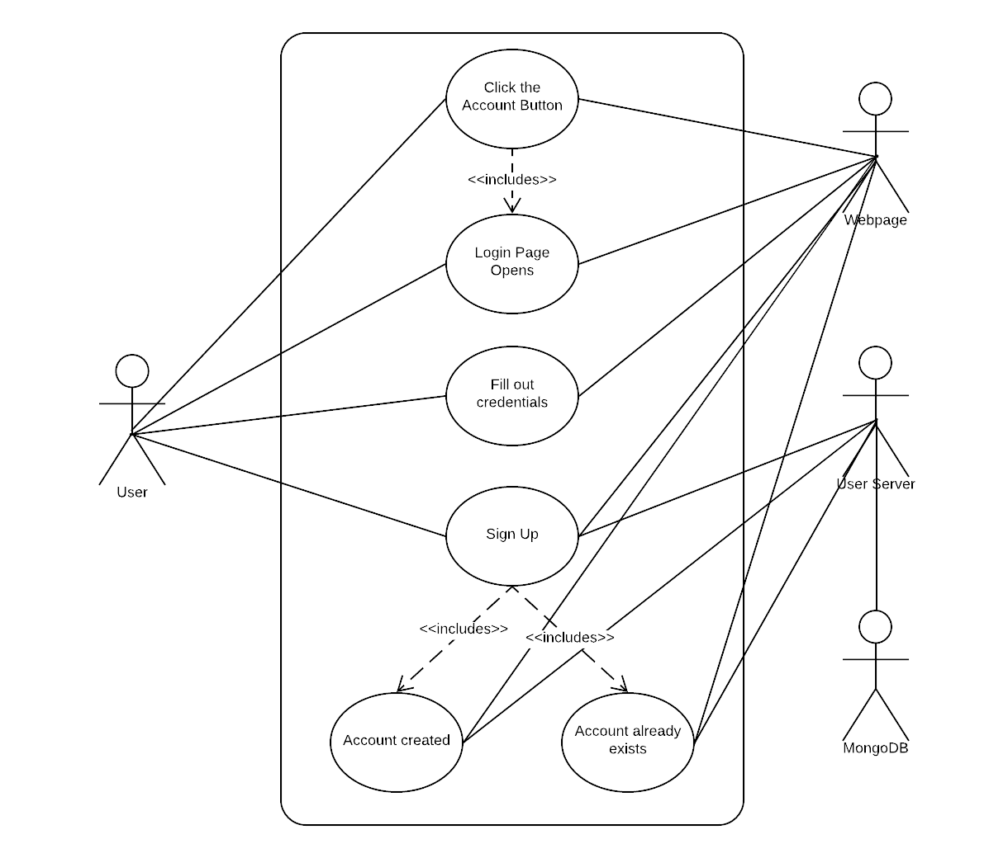

**Sequence Diagram**

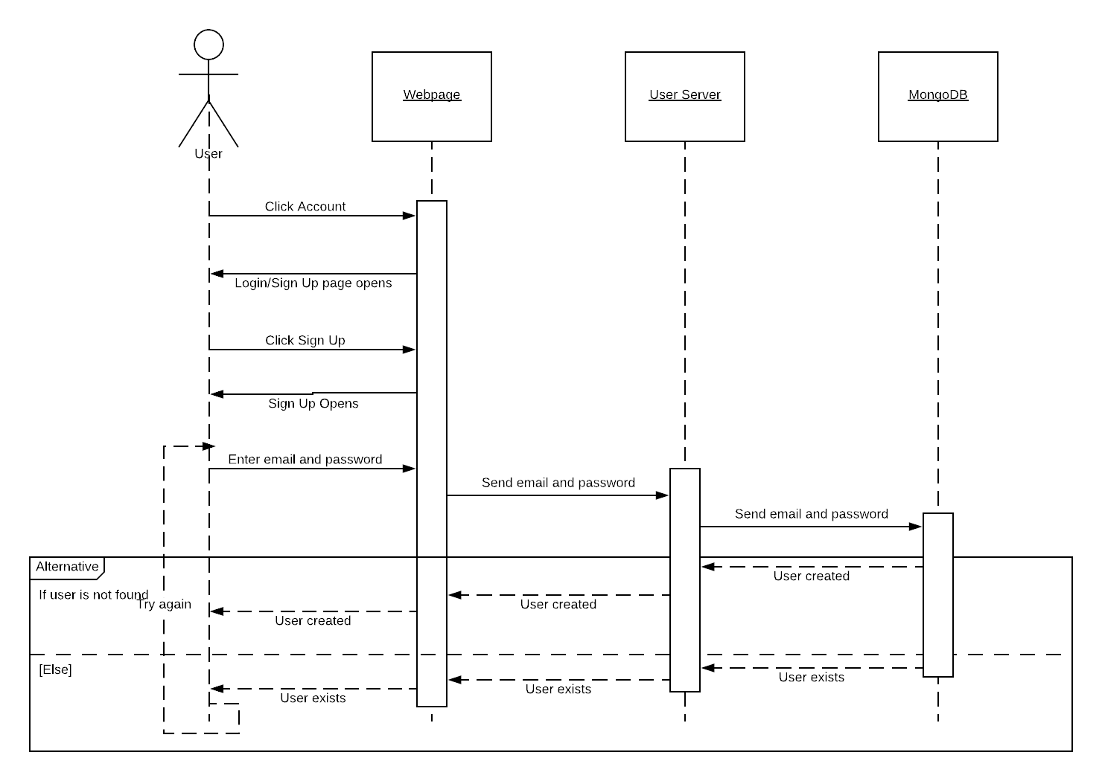

**Class Diagram**

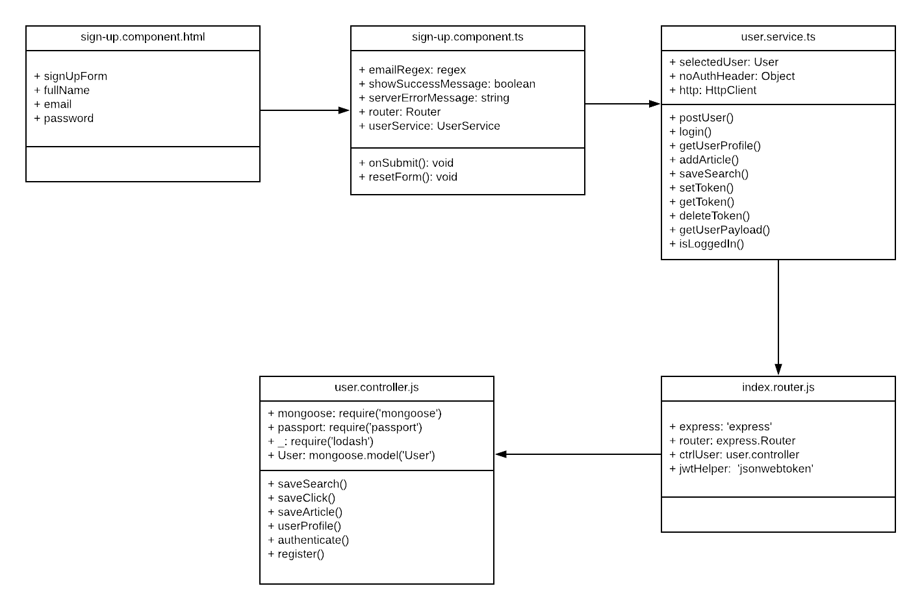

**Unit Test**

* Test case ID: NVOS-22-Create-Profile1
* Description/Summary of Test: This test was made to see if the a user profile is created
* Pre-condition: User has filled out name, e-mail, and password input boxes
* Expected Results: User will be prompted with message that says their account has been created and a new user will be added to the Mongo database
* Actual Result: User has been prompted with message that says their account has been created and a new user has been added to the Mongo database
* Status (Fail/Pass): Pass
* Test case ID: NVOS-22-Create-Profile2
* Description/Summary of Test: This test was made to see if the a user is prompted with message saying that another account has the same e-mail
* Pre-condition: User has filled out e-mail and password input boxes
* Expected Results: User will be prompted with message that says an account already exists with that e-mail address
* Actual Result: User has been prompted with message that says an account already exists with that e-mail address
* Status (Fail/Pass): Pass

**Visual User Guide**

